**Database Management System – cs422 DE**

**Lab 2 – Week 5**

-----------------------------------------------------------------------------------------------------------------

**This Lab is based on lecture 5 (chapters 14).**

* Submit your *own work* on time. No credit will be given if the lab is submitted after the due date.
* Note that the completed lab should be submitted in .doc, .docx, .rtf or .pdf format only.
* If you think that your answer needs more explanation to get credit then please write it down.   
  ---------------------------------------------------------------------------------------------------------------

Consider a relation with following attributes:

EmpNo : Employee Number

EmpName : Employee Name

EmpEmail : Employee Email

ProjNo : Project Number

ProjName : Project Name

EmpGrade : Employee Grade

HrlyRate : Hourly rate of compensation

Employees of the same grade receive the same hourly compensation

HrsWorked : Hours a particular employee worked on a particular project

1. Create this table and sample data in SQL Server. There must be at least 10 rows. There must be 3 to 6 Employees and 3 to 6 projects. You need to add the screenshot of the table showing all the rows.

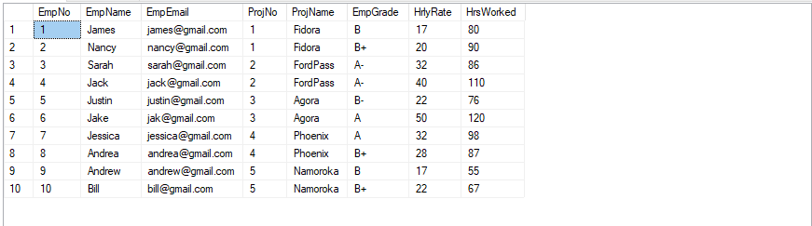

1. Find all functional dependencies.  
   ANS:

EmpNo ----> EmpName , Empemail , Empgrade , Hrlyrate

Empemail ----> EmpName , EmpNo, Empgrade , Hrlyrate

projNo --->projName

(EmpNo , projNo ) ---> HrsWorked

(Empemail, projNo ) ---> HrsWorked

1. Find all Candidate Keys.  
   ANS:

(EmpNo ,ProjectNo )

(Empemail ,ProjectNo )

1. Find a Primary Key.  
   ANS:

(EmpNo ,ProjectNo )

1. Find all partial dependencies.  
   ANS:

Empno -------> EmpName , Empemail , Empgrade , Hrlyrate

Empemail -------> EmpName , Empno , Empgrade , Hrlyrate

ProjNo ---> projName ,

1. Normalize to 2NF.  
   ANS:

Employee :

|  |  |  |  |  |
| --- | --- | --- | --- | --- |
| EmpNo | EmpName | Empemail | EmpGrade | Hrlyrate |

Project :

|  |  |
| --- | --- |
| projNo | projName |

Emp_proj:

|  |  |  |
| --- | --- | --- |
| projNo | EmpNo | HrsWorked |

1. Show new tables after 2NF (based on the sample data you created in 1 above). Screenshots of all the tables are required.

Employee

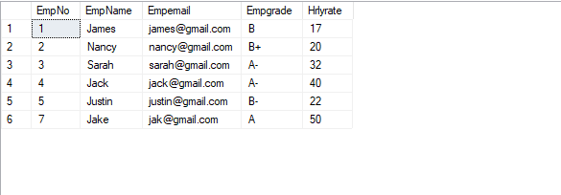

Project

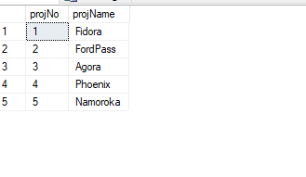

Emp-Proj

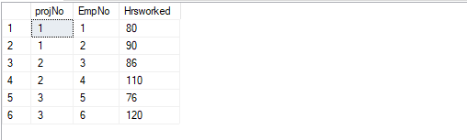

1. Normalize to 3NF.  
   ANS:

There is only one transitive dependency which is :

Empgrade ----> Hrlyrate

I will create a new table Grade containing this two attribute and we will keep only the attribute of Empgrade in our employee table so 3NF is :

Grade :

|  |  |
| --- | --- |
| EmpGrade | Hrlyrate |

Employee :

|  |  |  |  |
| --- | --- | --- | --- |
| EmpNo | EmpName | EmpEmail | EmpGrade |

Project :

|  |  |
| --- | --- |
| projNo | projName |

Emp_project :

|  |  |  |
| --- | --- | --- |
| projNo | EmpNo | HrsWorked |

1. Show new tables after 3NF (based on the sample data you created in 1 above). Screenshots of all the tables are required.

Grade:

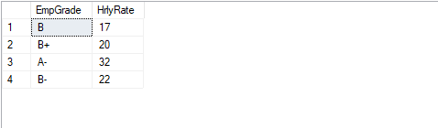

Employee:

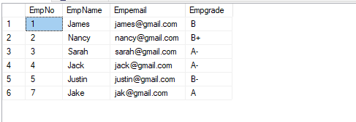

Project:



Emp-Proj

